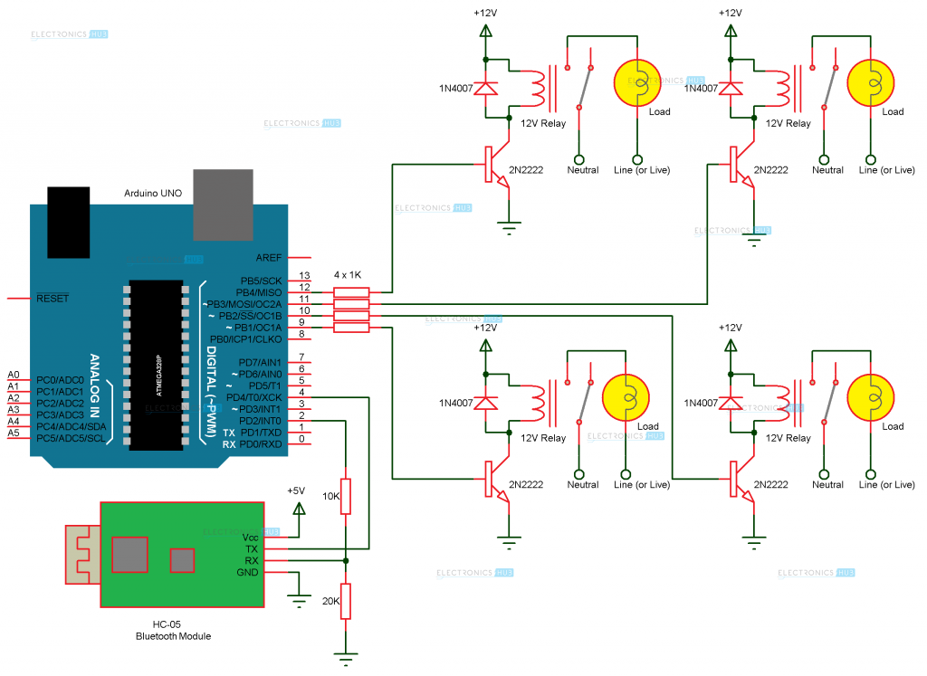

HOME AUTOMATION USING ARUDINO AND BLUETOOTH MODULE

SMART HOME TECHNOLOGY

research based laboratory

**TEAM MEMBERS:**

**GUIDED BY:**

Dr. V Chandra Jagan Mohan

V. RAHUL | 19951A0244

M.RAKESH | 19951A0246

B. RAKESH | 19951A0247

G.VIKAS| 19951A0212

# INDEX OF CONTEXT

1. Abstract
2. Introduction
3. Literature Survey
4. Existing System
5. Proposed method of Block Diagram
6. Hardware Requirements
7. Software Requirements
8. Implementation
9. Results and Explanation

10. Conclusion and Future Scope

11. References

# ABSTRACT

Smart homes are now becoming the requirement of the modern world. The days are now becoming thing of past when Smart Homes were only limited to sci-fi movies, it has gained much achievements and popularity over the last few decades. Home automation has given an entirely new meaning to living as compared to past days. Earlier all our home appliances such as television, AC, lights, fans etc. were operated by a specific remote controller for each appliance. There comes a problem too as handling all those remotes is hectic sometimes especially for the older and the disabled one. An overview of a solution to this problem is discussed that all such devices can also be operated by only remote controller rather than one remote controller per device. This universal controller can be easily implemented in a cost-effective way by just using any existing smartphone and an Arduino microcontroller via Bluetooth transmission. Thus, smartphone-based controlling devices eliminate the need for carrying many different remote controllers. In addition, controlling devices by speech avoids looking for various buttons/options while operating the devices. The study aims at developing a signal based smart home network for controlling the electronic appliances by the voice recognition system.

# INTRODUCTION

The electronic devices became part of the routine for each individual. A remote controller plays a vital role in handling these devices in the current era. The operations and functionality vary from device to device. Recognition of remote devices and buttons of remotes for an elderly and handicapped person is the mind-numbing job. Even for visually impaired people, it is difficult to recognize the remote controllers that belong to various home appliances. It can be achieved with costlier automation system of home appliances which is not affordable by a common man. Smart Home is a great innovation but it will be somehow restricted to The Elite Group. The real transformation is used successfully if it is made available and affordable for every economic group.

There are many possible solutions to this problem. But still, these types of homes are not very popular. The reason is that cost ineffective, instead of making a new product, the use of existing resources can make it much cheaper. Nowadays mobiles are the common gadgets that are used by every common man. It can be made as a good use of this resource as it already comes along with a microphone and smartness in various applications.

This project focuses on a web application for home automation using the Internet of Things. There is a network established for the house where any device connected within this network can control the other devices or home appliances. The prime feature of this paper is that some devices use motion sensors for ceiling fans that can vary according to the speed depending upon the temperature also the lights can be automatically turned on/off depending upon the inputs received from the light sensors. It is a secured application as without the user authentication no one can access the web application.

This project explains the technique which involves the engagement of PMRC (Programmable Multi-Remote Controller) along with the system which eliminates the problem faced during the orientation with other devices as it generates infrared signals in all directions which makes it easier to handle. The primary highlight of this paper is a human interactive voice recognizer system that basically works on a wireless network established between client and server architecture.

The performance parameters of the system will depend on the area covered by the wireless network, and the distance from the client system as well as the accent of the person. This project majorly describes earlier research work done on Home Automation as well as current ongoing research works. Apart from that, there is a various number of options by which the concept can be implemented such as ZigBee receiver, Ocean, Wi-Fi, Bluetooth and GSM. As a basic architecture, there will be a Smartphone and microcontrollers used.

LITERATURE SURVEY

The idea of automation can be dated back to 1800s, when Nikola Tesla developed the idea of having a remote control for vessel sand vehicles in 1898. Later with the advent of electrical appliances, the idea of home automation became more important. A.R.Al-Ali and M.Al-Rousan developed a Java based Home Automation System. It used Wi-Fi as a medium for communication between the hardware and software component. Its main disadvantage was that Wi-Fi range is limited and hence the user has to be in a certain range for operating the system. An android based HAS was developed in. It would use internet as a medium for connectivity. Its disadvantage was that the unavailability of internet would fail the entire system. Embedded smart home management scheme was presented in. It was based on use of Ethernet network. The system also had GSM support for the issue of unavailability of network. It was thus costly and hence was the only disadvantage. D.Naresh, B. Chakradhar & S. Krishnaveni presented the idea of Bluetooth based HAS in. It used arm processor (ARM9andARM7), and so the system has a complex architecture.

# EXISTING SYSTEM

The existing home automation system was developed byusing Global system for mobile communication andARM based technology. The home appliances arecontrolled using simple GSM based phone by sendingSMS. ARM based architecture has lack of wirelessfunction. The research provided here aims at studying thefeasibility of implementing an SMS- based control ofhome appliances using the GSM technology withouttrying to access other local networks.In GSM based architecture only text messages can be send. Voice recognition cannot be done in GSM. In ARM based home automation system, we cannot connect large number of peripherals. To overcome these limitations, we have come up with an approach, voice control home automation system using arudino and Bluetooth module HC-05.

PROPOSED METHOD OF BLOCK DIAGRAM

The system Model consists of modules like Bluetooth receiver module, Arduino UNO module, Relay module. The microcontroller, Bluetooth module and relay circuit are connected to the excitation source. The android application called Voice Control bot is opened on the smartphone, through which the user can send the commands to the microcontroller to operate the appliances. As soon as the microcontroller receives the command, it activates the relay specific to that command

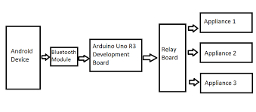

# PROPOSED METHOD OF BLOCK DIAGRAM

The application has options to search for the desired device if it is available. If the device is available and gets connected, the command can be sent by pressing the mic button in the app. The app takes the command and converts that command into a string. A String value is produced corresponding to each appliance associated with the given command and then this value is given to microcontroller. The ports on the microcontroller are used as a serial mode. After receiving the data, it extracts the input values and sends the signal to the parallel ports through which the relay gets operated as clearly shown in Fig.

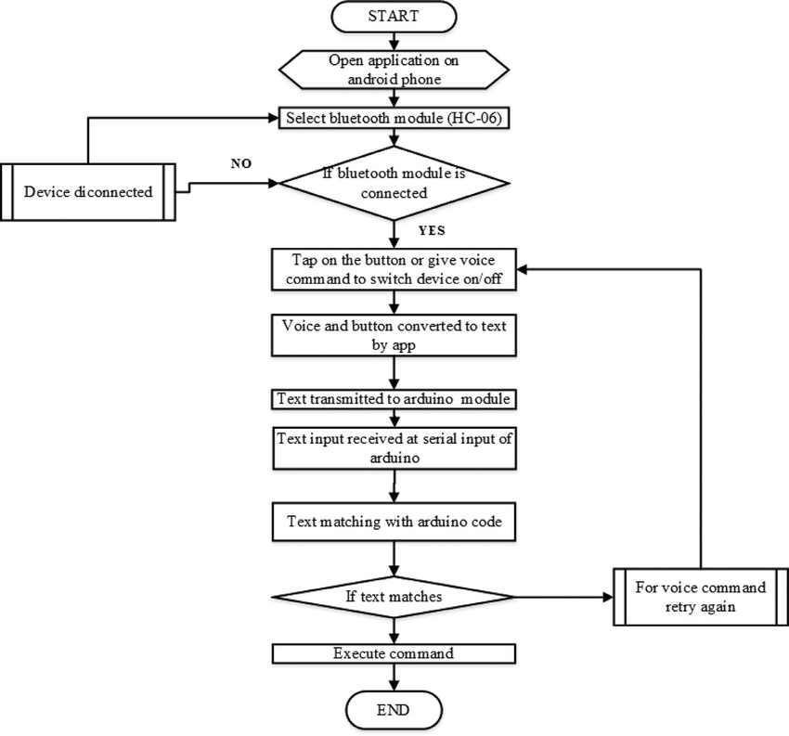

# HARDWARE REQUIREMENTS

* Smart phone or Tablet (Bluetooth enabled)
* BC547NPN Transistors
* Bluetooth module HC-05
* Relays
* 12V Power supply
* Resistors
* IN4007 diodes
* Arduino Uno

# SOFTWARE REQUIREMENTS

* Proteus 8
* Android Application
* Arduino compiler 1.6.9

# IMPLEMENTATION

The proposed system can be implemented in an effective way with affordable price and smart home concept. The system basically consists of two major components: one hardware component and the other one is a software component which is used as a communication module. Arduino Uno is the central component as it can act as an intermediate module (interfacing device) between hardware devices and the software. Each and every instruction is executed by the micro-controller through which the commands are processed. Fig. 6 shows the flow of the proposed system. The first step is to initialize the Bluetooth module which means connecting the Bluetooth module HC-05 to the smartphone after giving the power supply to it. Then the microcontroller is also energized to accept the commands via Bluetooth module. The next step is to give the command to the microcontroller that is Light On/Off, Fan On/Off and Switch On/Off by speaking these commands. When Light On/Off command is given, then microcontroller responds and the light goes On/Off. When Fan On/Off command is given, then microcontroller responds and Fan goes On/Off. Same happens in case of Switch On/Off command both the Light and Fan goes On/Off simultaneously.

Now if these three commands are given, then the microcontroller will act accordingly otherwise it will not work and wait for the correct command. For example, if Light On/Off command is given it will turn On/Off the Light. The same happens with Fan also when Fan On/Off command is given. Switch On/Off command is given to operate the Fan and light operate simultaneously.Pair device is used to select the desired device i.e. HC-05 from the list of available devices and the connect button is used to connect the app with the Bluetooth module. As soon as the connection is established the user is ready to send the command by pressing the Mic button in the app.

# IMPLEMENTATION

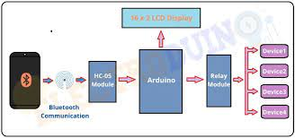

**CODE:**

**String voice;**

**void setup() {**

**Serial.begin(9600);**

**pinMode(6, OUTPUT);**

**pinMode(5, OUTPUT);**

**pinMode(4, OUTPUT);**

**}**

**void loop() {**

**while(Serial.available()){**

**delay(3);**

**char c = Serial.read();**

**voice+=c;}**

**if(voice.length() >0){**

**Serial.println(voice);**

**if(voice == "light on")**

**{digitalWrite(6, HIGH);}**

**else if(voice == "light off")**

**{digitalWrite(6, LOW);}**

**else if(voice == "fan on")**

**{digitalWrite(5, HIGH);}**

**else if(voice == "fan off")**

**{digitalWrite(5, LOW);}**

**else if(voice == "night lamp on")**

**{digitalWrite(4, HIGH);}**

**else if(voice == "night lamp off")**

**{digitalWrite(4, LOW);}**

**else if(voice == "all on")**

**{digitalWrite(4, HIGH);**

**digitalWrite(5, HIGH);**

**digitalWrite(6, HIGH);}**

**else if(voice == "all off")**

**{digitalWrite(4, LOW);**

**digitalWrite(5, LOW);**

**digitalWrite(6, LOW);}**

**voice = "";}**

**}**

# RESULTS AND EXPLANATION

The working of the device is very much user-friendly as the commands which were used are:

* Light ON/OFF (it controls the working of the Led from switch on to switch off).
* Turn ON/OFF (this command controls the operating of the fan that is ON/OFF).
* Switch ON/OFF (this command is used to control the operation of Led light and fan simultaneously).

The output for the same command with different accents; the prototype behaves in the same way. Command 1, Command 2 and Command 3 are different commands given as input. The different commands are identified correctly and operations are enabled accordingly. As the command changes the course of action also changes. The prototype works accordingly with a similar accent for the same word. Remaining words output left with no change***.***

# CONCLUSION AND FUTURE SCOPE

Nowadays, remotely controlled devices at home are inevitable for the present generation of technology. The comfort and instant action make the usage of these controllers in the day to day life. Instead of using different controllers for various devices, a common controller can be used to control all the device. And it can be controlled using a smart phone, a most commonly used handheld device is an added advantage. The control of home appliances is handed over to smartphones with the ability to recognize speech and operate accordingly to control the devices. Smartphones send the verbal command through the Bluetooth channel to a device (Arduino) which acts according to the command given. These verbal commands are designed keeping in mind that these commands should be easy to speak and remember.

The simplicity of the commands makes this project user-friendly. The idea is tested successfully using a smartphone, Led and a Fan connected to the circuit. With the development of this project for various electrical and electronic appliances, the life of elderly and disabled people can be made much more comfortable. For the younger and abled people, their life will be much more luxurious and comfortable. The large community people can be benefited by the universal controller enabled with speech recognition***.*** It is just a module for the idea of a home appliance controller. In the near future, more advanced features can be added to this module for the greater coverage area, wide range of commands which make it more efficient. Gesture control makes more versatile and also multilingual speech recognition can contribute to the great success for home automation.

REFERENCES:

1. <https://www.labcenter.com/>
2. <https://www.arduino.cc/en/software>
3. <https://www.youtube.com/watch?v=Kz8hKM4lnFk>